**PayOS Integration Guide with Ngrok for Go-Phone Project**

**1. Introduce**

* [**PayOS**](https://payos.vn/docs/): Online payment gateway, integrated into Go-Phone project to process transactions.
* [**Ngrok**](https://ngrok.com/): Tool to create tunnel from internet to local machine, allowing PayOS to send webhook to local.

**2. Setup PayOS**

**2.1 Create account and get API key**

[Register](Đăng%20Register%20ý) account PayOS (refer to: <https://payos.vn/docs/huong-dan-su-dung/tao-tai-khoan-payos>).

1. Go to PayOS Developer admin page, create **Client ID**, **API Key** and **Checksum Key**.

**2.2 Configuration in .env**

In the .env file, configure:

# PayOS  
PAYOS_CLIENT_ID=<<Your Client ID>>  
PAYOS_API_KEY=<<Your Api Key>>  
PAYOS_CHECKSUM_KEY=<<Your Checksum Key>>

**3. Setup Ngrok**

**3.1 Cài đặt Ngrok**

* Download from <https://ngrok.com/download>.
* • Video tutorial on installing and auth token of Ngrok: <https://www.youtube.com/watch?v=aFwrNSfthxU>

**3.2 Open tunnel**

Go-Phone run on port 8888. Let PayOS call webhook to local:

$: ngrok http 8888

Ngrok will generate a URL of the form:

https://<random-id>.ngrok-free.app

**3.3 Update webhook URL in PayOS**

* Go to PayOS dashboard.
* Update webhook URL to:

https://<random-id>.ngrok-free.app/api/webhooks/payos

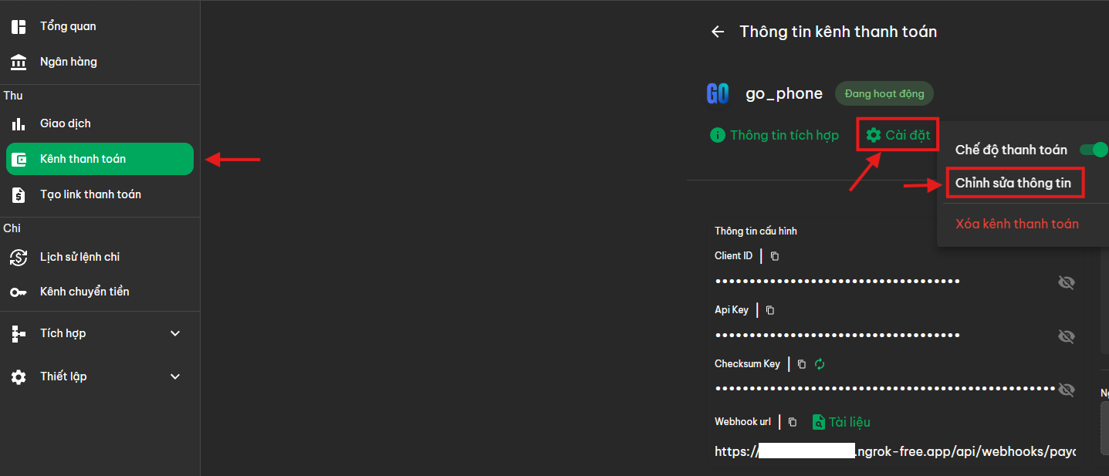

**4. Testing**

**4.1 Create test order**

* Call API to create order from Postman:

POST http://localhost:8888/api/v1/payment/create

* Returns PayOS payment URL.

**4.2 Trial payment**

* Access the returned URL, select the test payment method.

**4.3 Check webhook**

* After successful payment, PayOS will call webhook to Ngrok address.
* Check the application log using:

$: docker logs -f go_phone-app

* Make sure logs show webhook data.

**5. Common errors**

**5.1 Webhook not called**

* Cause: Ngrok is not running or webhook URL is not updated in PayOS.
* Solution: Check the Ngrok tunnel again and update the webhook URL.

**5.2 Checksum validation error**

Cause: Incorrect checksum-key or modified payload data.

* Solution: Make sure the key in application.yml is correct and the code verify checksum is correct.

**5.3 PayOS Unconnected App**

* Cause: Wrong client-id or api-key.
* How to handle: Check the information in the PayOS dashboard again.